Read the following from Schaum’s series:
Expression Evaluation: 6.9 – 6.14,
Quicksort: 6.14 – 6.15 and then see project QuickSort,
Heap and Heapsort: https://en.wikipedia.org/wiki/File:Heapsort-example.gif
and then see project HeapSort,
Cycle sort: The cycle sort algorithm is motivated by something called a cycle decomposition. Cycle decompositions are best explained by example. Let's suppose that you have this array:
4 3 0 1 2
Let's imagine that we have this sequence in sorted order, as shown here:
0 1 2 3 4
How would we have to shuffle this sorted array to get to the shuffled version? Well, let's place them side-by-side:
0 1 2 3 4
4 3 0 1 2
Let's start that the beginning. Notice that the number 0 got swapped to the position initially held by 2. The number 2 in turn got swapped to the position initially held by 4. Finally, 4 got swapped to the position initially held by 0. In other words, the elements 0, 2, and 4 all were cycled forward one position. That leaves behind the numbers 1 and 3. Notice that 1 swaps to where 3 is and 3 swaps to where 1 is. In other words, the elements 1 and 3 were cycled forward one position.
As a result of the above observations, we'd say that the sequence 4 3 0 1 2 has cycle decomposition (0 2 4)(1 3). Here, each group of terms in parentheses means "circularly cycle these elements forward." This means to cycle 0 to the spot where 2 is, 2 to the spot where 4 is, and 4 to the spot where 0 was, then to cycle 1 to the spot where 3 was and 3 to the spot where 1 is.
If you have the cycle decomposition for a particular array, you can get it back in sorted order making the fewest number of writes by just cycling everything backward one spot. The idea behind cycle sort is to try to determine what the cycle decomposition of the input array is, then to reverse it to put everything back in its place.
Part of the challenge of this is figuring out where everything initially belongs, since a cycle decomposition assumes you know this. Typically, cycle sort works by going to each element and counting up how many elements are smaller than it. This is expensive - it contributes to the Θ(n2) runtime of the sorting algorithm - but doesn't require any writes.
Now see project Cyclesort,

Introduction of Tree: 7.1 – 7.5 (upto extended tree),

Height, depth and level of a node in a tree: http://typeocaml.com/2014/11/26/height-depth-and-level-of-a-tree/

Tree traversal: ONLY (7.9 – 7.12) and then project TreeTraversalIterative

Header Nodes and Threads: 7.20 – 7.23,

BST: 7.23 – 7.35,

AVL Tree: 7.35 to 7.46,
m-way search tree: 7.46 – 7.51,
B tree: 7.51 – 7.55,
Heap and Heapsort: 7.55 – 7.65,
Red-Black tree:
It is a self-balancing binary seach tree.
Comparison of Red-Black tree with AVL Tree:
The AVL trees are more balanced compared to Red Black Trees, but they may cause more rotations during insertion and deletion. So if your application involves many frequent insertions and deletions, then Red Black trees should be preferred. And if the insertions and deletions are less frequent and search is more frequent operation, then AVL tree should be preferred over Red Black Tree.
Some important points about red-black tree:
- Color of a NULL node is considered as BLACK.
- Tools for insertion or deletion: Recoloring and rotation
- When a black node is deleted and replaced by a black child, the child is marked as double black.
- During rotation with the rules of AVL tree, the node which gets promoted to upper level (one or two levels upper) is recolored black and the node which gets demoted to lower level (one level lower) is colored red.
- The notion of double black comes only in case of deletion of a node. If a black node is promoted to upper level, it doesn’t becomes a double black.
- Red + Double black => Black
Every node follows following rules:
- Every node has a color either red or black.
- Root of tree is always black.
- There are no two adjacent red nodes (A red node cannot have a red parent or red child).
- Every path from root to a NULL node has same number of black nodes.
Insertion in Red-Black tree:
Perform standard BST insertion and make the color of newly inserted nodes as RED. Suppose the newly inserted node is x. Now there are three conditions:
- If the level of x is 1 (means x is root node): change color of x as BLACK (Black height of complete tree increases by 1).
- If the level of x is 2 (means the parent of x is root node): No problem. The black height of the tree remains unchanged.
- If the level of x is more than 2: Two conditions:
3.1: If x’s uncle is RED:
(I) Change color of parent and uncle as BLACK.
(ii) color of grand parent as RED.
(iii) Change x = x’s grandparent, repeat steps 1, 2 and 3 for new x.
3.2: If x’s uncle is BLACK: Do AVL rotation and apply the following rule:
During rotation with the rules of AVL tree, the node which gets promoted to upper level (one or two levels upper) is recolored black and the node which gets demoted to lower level (one level lower) is colored red.
Deletion in Red-Black tree:
In delete, the main violated property is, change of black height in subtrees as deletion of a black node may cause reduced black height in one root to leaf path. To understand deletion, notion of double black is used. When a black node is deleted and replaced by a black child, the child is marked as double black. The main task now becomes to convert this double black to single black.
To delete a node from the red-black tree, perform standard BST delete. When we perform standard delete operation in BST, we always end up deleting a node which is either leaf or has only one child (For an internal node, we copy the successor and then recursively call delete for successor, successor is always a leaf node or a node with one child). So we only need to handle cases where a node is leaf or has one child. Let v be the node to be deleted and u be the child that replaces v (Note that u is NULL when v is a leaf and color of NULL is considered as Black). Three cases may occur:
- If either u or v is red: We mark the replaced child as black (No change in black height).
- If Both u and v are Black: Color u as double black. Now our task reduces to convert this double black to single black. Note that If v is leaf, then u is NULL and color of NULL is considered as black. So the deletion of a black leaf also causes a double black.
Let sibling of the double black node u be s. Do following while the current node u is double black or it is not root:
2.1: If sibling s is black and at least one of sibling’s children is red: four cases:
(a) if sibling is left child of its parent and its left or both child are red: left-left rotation,
(b) if sibling is left child of its parent and its right child is red: left-right rotation,
(c) if sibling is right child of its parent and its right or both child are red: right-right rotation,
(d) if sibling is right child of its parent and its left child is red: right-left rotation,
2.2: If sibling is black and its both children are black: Recolor the sibling as red, and recur for the parent if parent is black. if parent was red, then we didn’t need to recur for prent, we can simply make it black (red + double black = single black)
2.3: If sibling is red: First perform a left-lef or right-right AVL rotation with promotion-demotion-recoloring scheme. Then it becomes case 2.2 with black sibling and its both children black. Now solve it.
- If the double black node u is root, make it single black and return (Black height of complete tree reduces by 1).

Tail recursion:
Must see how to write a factorial program in tail recursion.
http://www.geeksforgeeks.org/tail-recursion/
http://www.geeksforgeeks.org/tail-call-elimination/

Find the length of the linked list(iterative and recursive):
http://quiz.geeksforgeeks.org/find-length-of-a-linked-list-iterative-and-recursive/

Print a linked list in reverse order:
http://www.geeksforgeeks.org/write-a-recursive-function-to-print-reverse-of-a-linked-list/

Very Very Imp
Reverse the linked list (Iterative and Recursive both):
http://www.geeksforgeeks.org/write-a-function-to-reverse-the-nodes-of-a-linked-list/
Iterative:
Node reverse(Node head) {
prev = null, next = null, curr = head;
while (curr != null) {
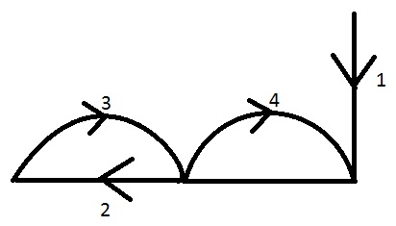

}
return prev;
}
Recursive:
public static Node recursiveReversive(Node head) {
if (head == null || head.next == null) {
return head;
}
Node remaining = recursiveReversive(head.next);
head.next.next = head;
heda.next = null;
return remaining;
}

Reverse the doubly linked list:
http://www.geeksforgeeks.org/reverse-a-doubly-linked-list/
Iterative:
temp = null, curr = head;
while (curr != null) {
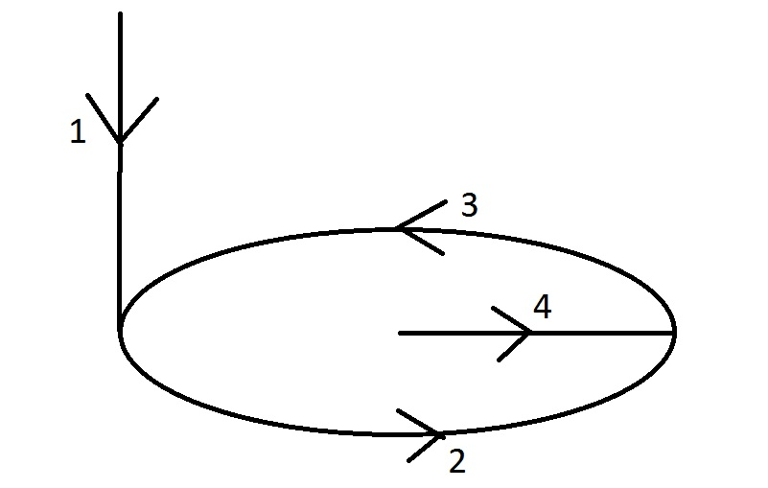

}
head = temp→prev;

Very Very Difficult
Reverse the linked list in a group of given size:
Node groupReverse(Node head, int k) {
prev = null, next = null, curr = head;
int count = 0;
while (count < k && curr != null) {

count++;
}
if (next != null)
head.next = reverse(next, k);
return prev;
}
http://www.geeksforgeeks.org/reverse-a-list-in-groups-of-given-size/

Detect and remove loop in a linked list (four techniques):
http://www.geeksforgeeks.org/detect-and-remove-loop-in-a-linked-list/

The great tree list recursion problem:
http://www.geeksforgeeks.org/the-great-tree-list-recursion-problem/

